// State Management , Context Api , Redux Flux

// Redux , actions reducers

// UI ,

// let x = 0 , actioncreators , dispatch what need to be done to reducers

// reducers are functions are going to chnage state of the x

// depending upon action type & payload (para)

// We can use Redux to make API calls

// actioncreators sync

// we need to make api calls async

// thunk & saga

Making so many calls cud be tricky and messy in thunk

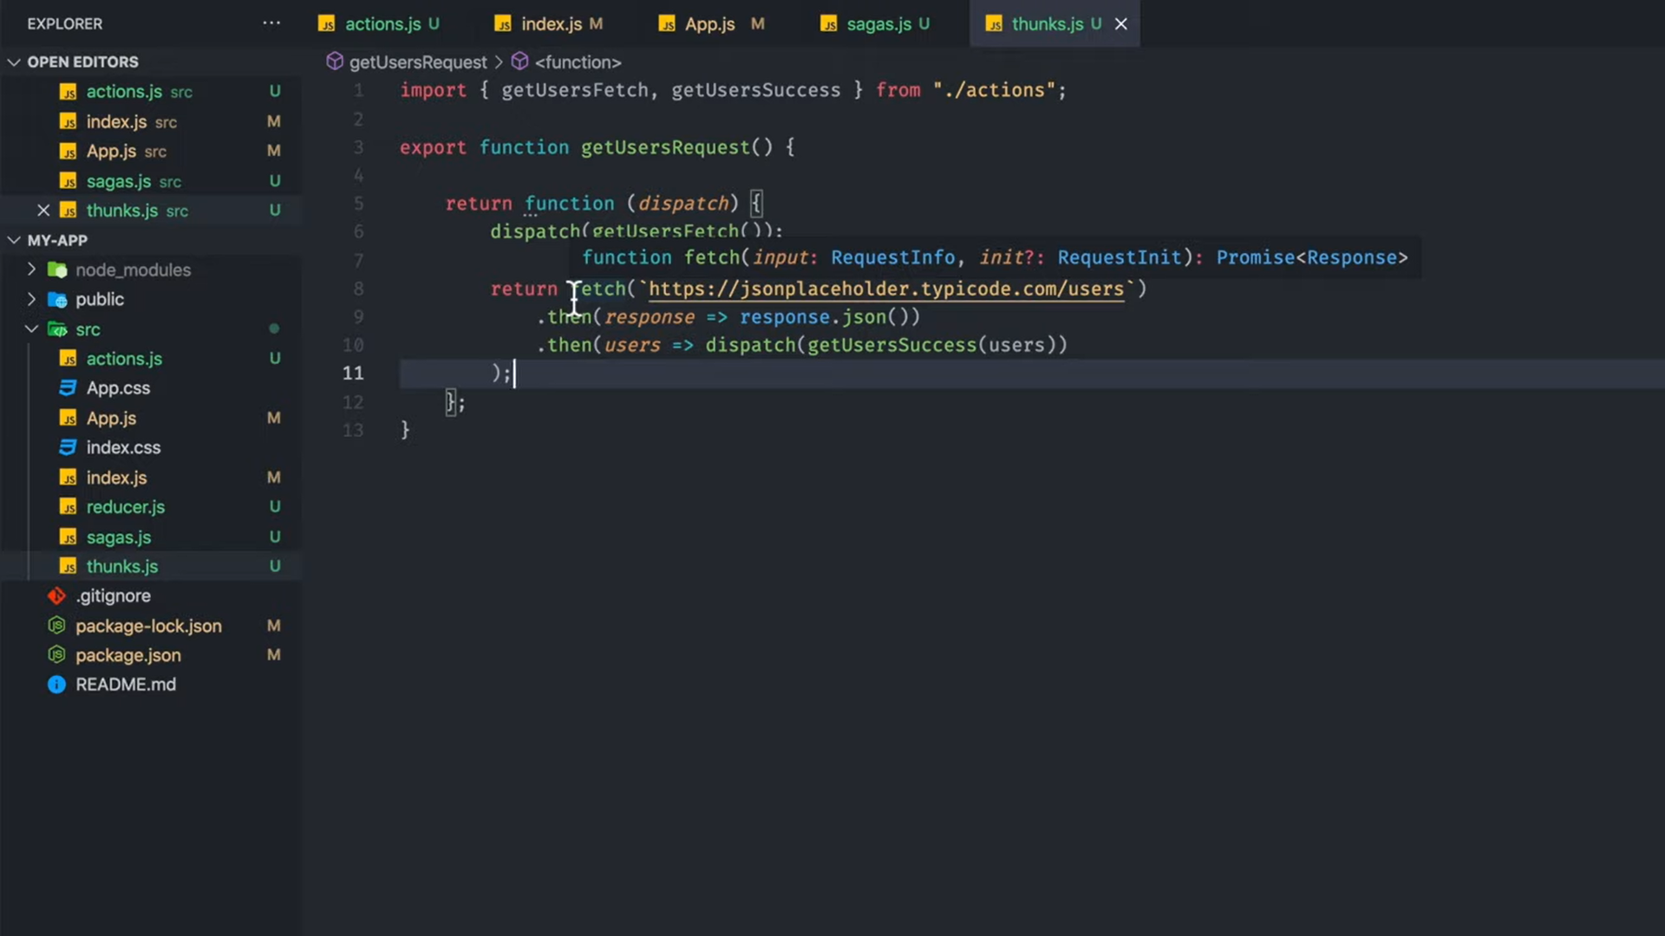

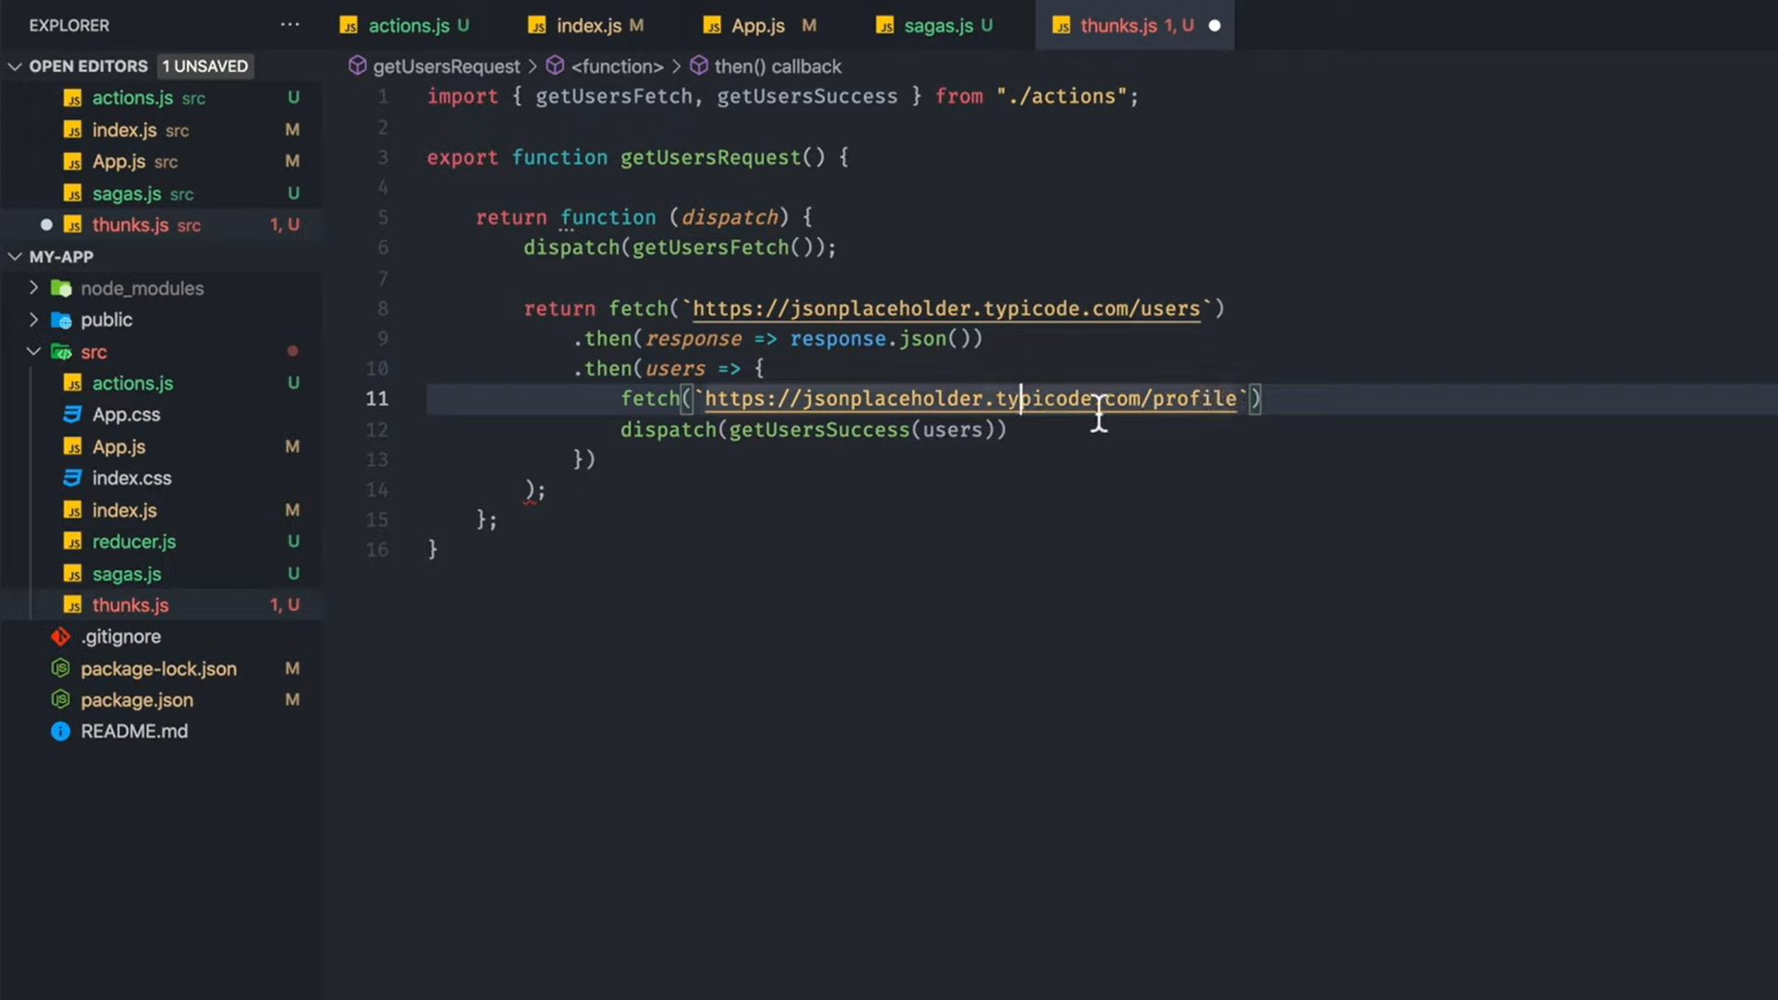

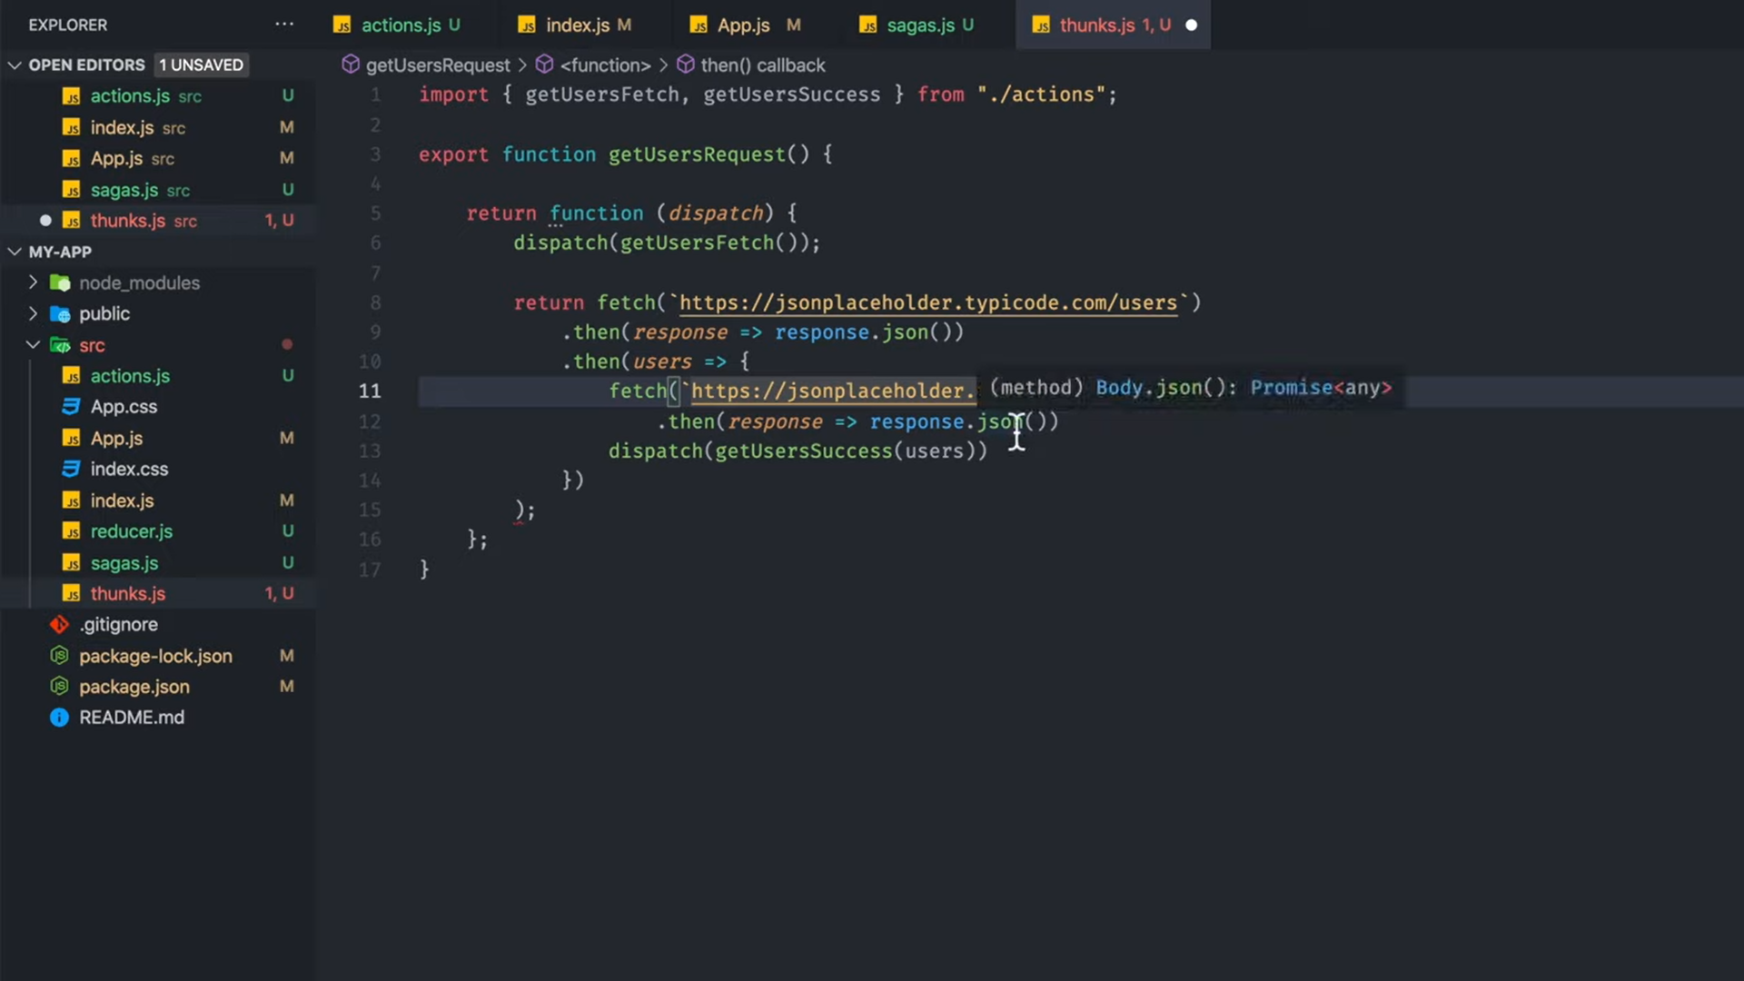

There cud be problem of callback hells , passing parameters to the child elements / calls

Getting nested

In case of Saga

Make 2nd call after 1st call because it uses generator functions which uses yield

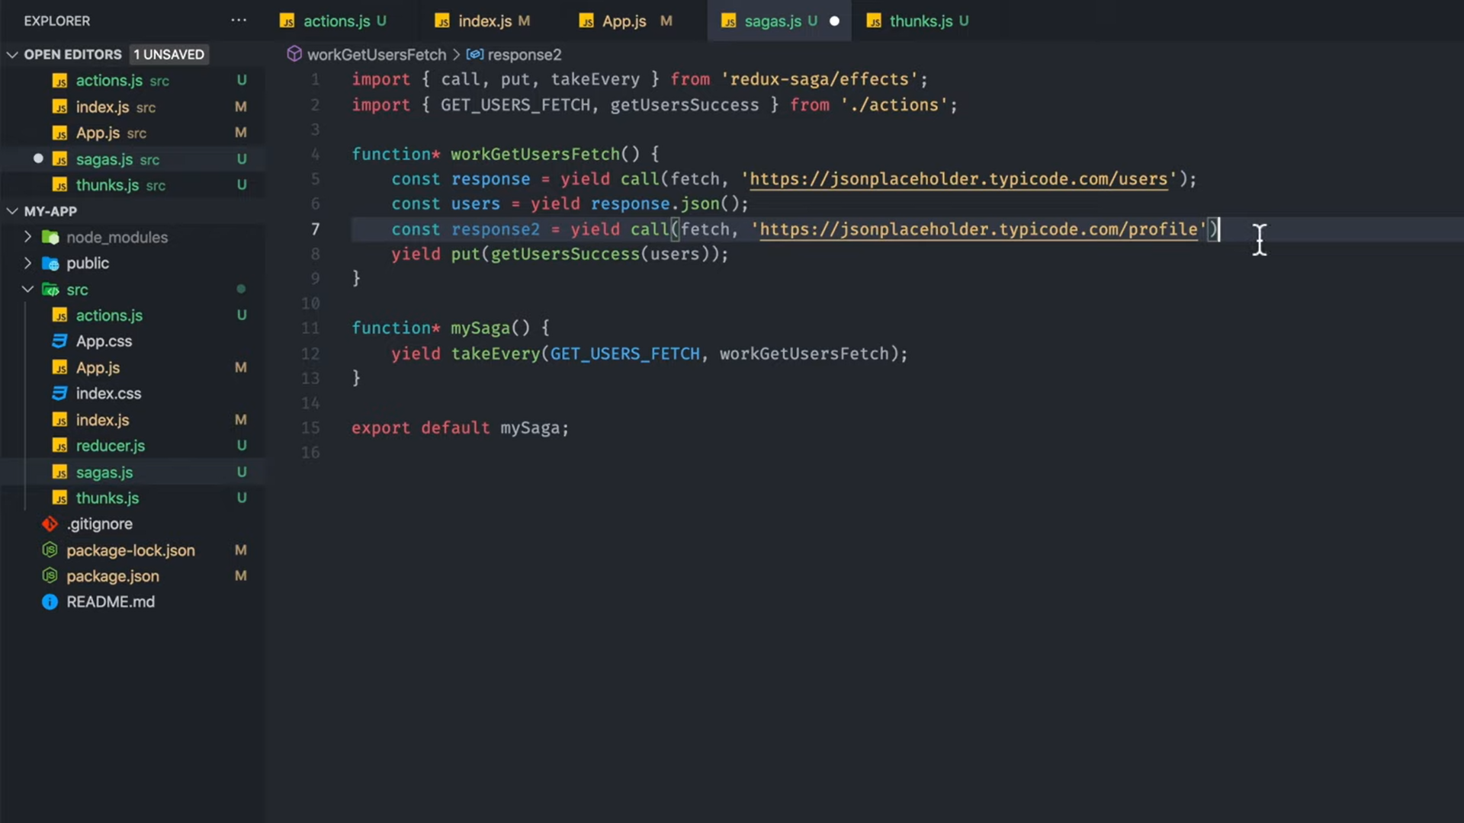

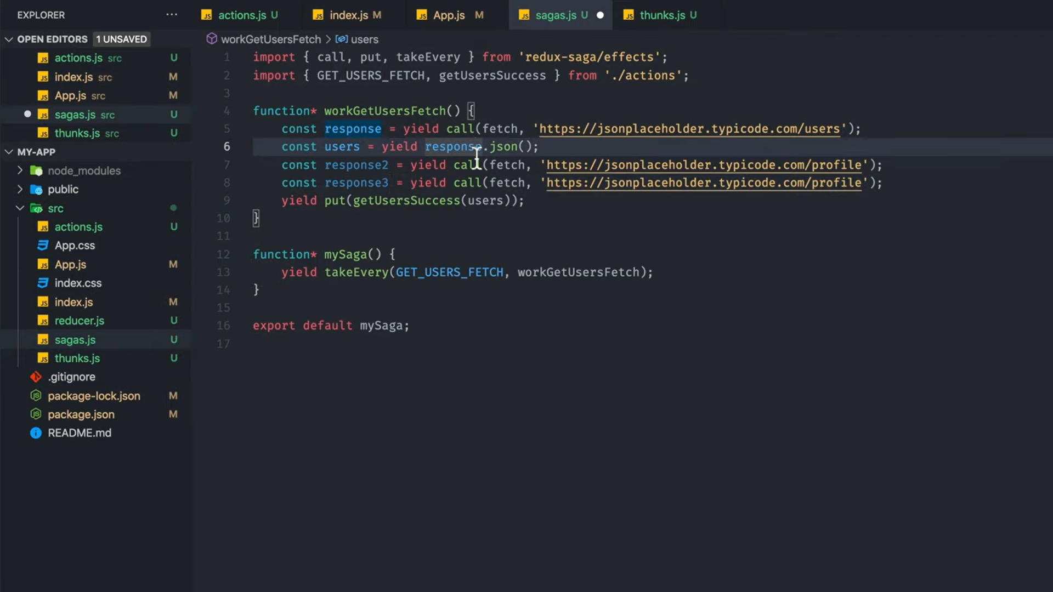

Its like async await

Thunk looks like JS

